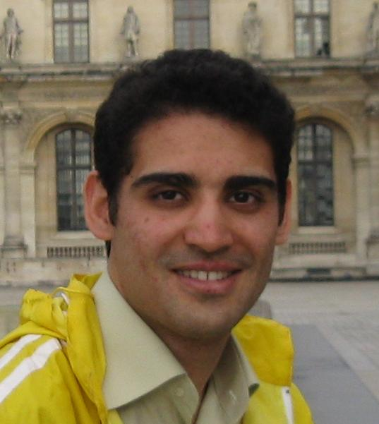
Mahmoud Rahat.V
Curriculum Vitae

Contact
Computer Engineering & Information Technology Department,
Amirkabir Univ. of Technology,
Tehran, Iran.
Cell Phone: +98 912 725 2897
Home Phone: +98 2654 8338
Email: mahmoud.rahat@aut.ac.ir

Personal Information
Gender: Male
Date of birth: 1st of Jun, 1985
Place of birth: Tehran, Iran
Marital Status: Single
Present Citizenship: Iran

Education
M.S. Artificial Intelligence
Start Date: October 2007. End Date: May 2010
Amirkabir University of Technology (Tehran Polytechnic), Tehran, Iran
Thesis: Real-time face recognition for home robots with combination of 2D and 3D images captured by stereo camera.
First Advisor: Prof. S. Shiry
Specialization: Robotics, Machine Vision
Second Advisor: Prof. R. Ebrahimpour
Specialization: Human and Machine Vision, Neural Networks, Combining Classifiers
GPA: 16.56/20

B.S. Computer Science,
Start Date: September 2003. End Date: July 2007
Tehran University, Tehran, Iran
Advisor: Prof. Mashayekh
GPA: 15.82/20

Research Interests
- Machine Vision
- Image Processing
- Pattern recognition
- Human Machine Interaction
- Machine Learning
- Mobile Robots
- Face Recognition & detection
- Stereo Vision

Publications
- M. Rahat Varnousfaderani, H. Mahzarnia, "Real-time Face Recognition in Home Robots", International Robocup Iran Open Symposium Proceedings, RIOS09, Qazvin, Iran, 2009
- M. Rahat, S. Shiry, "Robust Human Tracking Using Combination of Camshift and Range Data Analysis for Mobile Service Robots", International Robocup Iran Open Symposium Proceedings, Tehran, Iran, 2010
- M. Rahat, S. Shiry, R. Ebrahimpour, “Improving 2D Boosted Classifiers Using Depth LDA For Robust Face Detection”, International Conference On Computer Vision Theory And Applications (VISAPP) 2010, Angers, France (Accepted not published)
- M. Rahat, S. Shiry, R. Ebrahimpour, “Robust Face Detection with combination of 2D and depth data”, 15th International CSI Computer Conference (CSICC) Feb. 2010, Tehran.
- Masoum Paper SoCPaR 2010 paper:
Authors : Reza Ebrahimpour, Mohammad Shams EsfandAbadi, Masoom Nazari, Ali Amiri, Mehdi Azizi and Mahmoud Rahat
Title : Single Training Sample Face Recognition Using Fusion of Gabor responses
- Hadi Mahzarnia, Seyyed Mohammad Ghafarian, Mahmoud Rahat, Hedayat Vatankhah, Seyed Mahdi Hosseini, Farshad Einabadi, Mahdi Nejadgholi, Alireza Shafaei, and Saeed Shiry Ghidary, “Sourena @Home Team Description Paper 2010”, Technical Report, International RoboCup Proceeding, Singapore, June 2010
- Hadi Mahzarnia, Mohsen Malmir, Mahmoud Rahat, Seyyed Mohammad Ghafarian, Amin Yazdani, Hedayat Vatankhah, Seyyed Mehdi Hosseini, Habibollah Abdollahypoor, Kaveh Kavianpour, Zahra Narimani, Jafer Abdi, and Saeed Shiry Ghidary, “Sourena @Home Team Description Paper 2009”, Technical Report, International RoboCup Proceeding, Graz Austria, June 2009
- H.Mahzarnia, M.Rahat, A.Yazdani, K.Kavianpour, H.Abdollahi, Z.Narimani, “Sourena @Home Team Description Paper 2008”, Technical Report, International RoboCup Proceeding, Suzhou, China, July 2008.

Honors & Awards
- Ranked 1st in Robocup@Home League, RoboCup IranOpen Competitions, as a member of team SOURENA, Qazvin, Iran, 2009
- Finalist of Robocup@Home League, International RoboCup Competitions, as a member of team SOURENA, Suzhou, China, 2008
- Participated in International RoboCup Competitions, Robocup@Home League, for 3 years as member of team SOURENA, Suzhou China 2008, Graz Austria 2009, and Singapore 2010
- Participated in International RoboCup IranOpen Competitions, @Home League, for 3 years as member of team SOURENA, Tehran Iran 2008-2010
- 4th place award in 20th Kharazmi RoboCup competition in Humanoid league, Tehran, Iran, 2009
- Reviewer Of 13th Iranian Student Conference on Electrical Engineering (ISCEE) 15-17 Sep, 2010
- Participating in Machine Learning and artifitual intelligence Courses in Coursera.org.

Abilities and experiences
- Member of Robotics Research Laboratory, Department of Computer Engineering and IT, Amirkabir University of Technology (http://ceit.aut.ac.ir/athome/index.htm), Start Date: November 2007, End Date: Still In Progress.
- Designing the software of “Sourena Home Robot”, Robotics Research Laboratory., Amirkabir University of Technology (Tehran Polytechnic), 2008
- Experienced with OpenCV (a library of programming functions for computer vision)
- Experienced with CMUcam3 (an Open Source Programmable Embedded Color Vision Platform)
- Experienced with Bumblebee-2 (Point Grey Research's Stereo Vision camera systems)
- Experienced with Mobile Robots (like SOURENA @Home Robot)
- Working with Robotic Arms (like AX12-SmartArm)

Teaching
- Teacher Assistant in Machine Learning course, Amirkabir University of Technology, Fall 2009
- Teacher Assistant in Data Structure course, Tehran University, Spring 2006
- Instructor of Computer Programming and Data Structure courses, Parand Islamic Azad University, Fall 2009

Computer Skills
- Programming: Experienced with C++, Visual C#, and MATLAB‌, Familiar with Java.
- Web Programming and Database: ASP.NET, Microsoft SQL Server
- 3D Graphical Engine: Experienced with OpenCV
- Operating Systems: Experienced with Windows, Familiar with Ubuntu
- General utilities & Graphic Software: Microsoft Office, PhotoShop, Familiar with 3d Studio Max

Language Spoken
- Persian: Native
- English: Fluent
- TOEFL Exam: Planed for 12th of September

Interests And Hobbies
- Playing soccer, volleyball, swimming, and table tennis
- Mountain climbing
- Travelling
- Watching Movies
- Reading Books

References
- Reza Ebrahimpour:
School of Cognitive Sciences (SCS) Institute for Research in Fundamental Sciences (IPM), P.O. Box 19395-5746, Niavaran, Tehran, Iran
Email: ebrahimpour@ipm.ir
Web: http://www.ipm.ac.ir/personalinfo.jsp?PeopleCode=IP0400031

- Saeed Shiry Ghidary:
Computer Engineering & Information Technology Department, Amirkabir Univ. of Technology (Tehran Polytechnic), P.O. Box 15875-4413, 424, Hafez Ave, Tehran-Iran
Email: shiry@aut.ac.ir
Web: http://ceit.aut.ac.ir/~shiry/

